Experiment Number : 8 Date: 26-02-26

Implementation of Packages in Java

Aim:
To Write a Java program to implement built-in, user-defined packages and accessing all classes in a package.

PRE LAB EXERCISE
QUESTIONS
- What is java.util package and what collection framework does it contain?
java.util is one of the core utility packages in Java.
It contains:
- Collection Framework
- Utility classes (Scanner, Random, Date, Arrays, Collections, etc.)
- Data structures
- What are the two types of packages in Java?
Java has two types of packages:
1. Built-in Packages
These are already provided by Java.
Examples:
- java.util
- java.io
- java.lang
- java.sql
- java.net
2. User-defined Packages
Created by the programmer using:
package myPackage;
These help in:
- Organizing classes
- Avoiding name conflicts
- Reusing code

IN LAB EXERCISE
Objective
To understand and implement the concepts of built-in, user-defined packages and accessing all classes in a package in Java.
Built-in Packages comprise a large number of classes that are part of the Java API. Some of the commonly used built-in packages are:
- java.lang: Contains language support classes(e.g, classes that define primitive data types, math operations). This package is automatically imported.
- java.io: Contains classes for supporting input/output operations.
- java.util: Contains utility classes that implement data structures such as Linked Lists and Dictionaries, as well as support for date and time operations.
- java.applet: Contains classes for creating Applets.
- java.awt: Contains classes for implementing the components for graphical user interfaces (like buttons, menus, etc).
Source Code
package unit2;
import java.util.Random;
public class randomno {
public static void main(String[] args) {
Random rand = new Random();

int number = rand.nextInt(100);
System.out.println("Random number: " + number);

}

}
Output
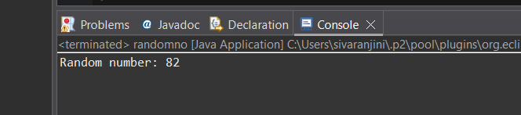
User-defined Packages are the packages that are defined by the user.
Source code
package com.myapp;
public class Helper {
public static void show() {
System.out.println("Hello from Helper!");
}
}
package unit2;
import com.myapp.Helper;
public class user {
public static void main(String[] args) {
Helper.show();
}
}

Output:
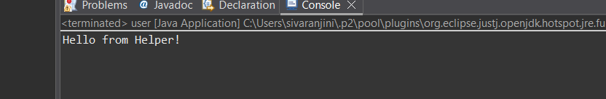//Importing all classes from a package.
Source code
package unit2;
import java.util.Vector;
public class Usage {
public Usage() {
Vector v = new Vector();
java.util.ArrayList l = new java.util.ArrayList();
l.add(4);
l.add(6);
l.add(7);
System.out.println(l);
}
public static void main(String[] args) {
new Usage(); // FIXED
}
}
Output
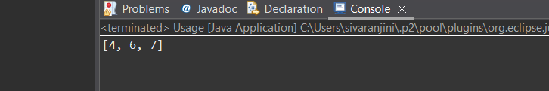POST LAB EXERCISE
- What will happen if two classes in different packages have the same name and are imported in a Java file?

Java will throw an ambiguity error if both classes are imported normally.
Example:
import pack1.Student;
import pack2.Student; // ❌ ERROR: Ambiguous reference
Java cannot decide which Student class you want → compile-time error.

How to solve it?
Use fully qualified class name
- What is the purpose of using packages in Java?

Purposes of packages:

1. Organize classes logically
Helps group related classes together.

2. Avoid naming conflicts
Two classes with the same name can exist in different packages.

3. Provide access control
Using public, default, protected within package structure.

4. Promote reusability
Code in packages can be reused across projects.
- Which built-in Java package would you use if you want to create a GUI window and display a message?
- java.util
- java.sql
- java.awt
- java.net
C. java.awt
Why?
java.awt (Abstract Window Toolkit) is a built-in Java package used to create:
- GUI windows
- Buttons
- Frames
- Dialog boxes
- Labels

ASSESSMENT

Description | Max Marks | Marks Awarded
Pre Lab Exercise | 5
In Lab Exercise | 10
Post Lab Exercise | 5
Viva | 10
Total | 30
Faculty Signature

Experiment Number : 9 Date: 21-02-26

Implementation of a Java Program to import packages using different methods

Aim:
To Write a Java program to import packages using different methods for different use cases.

PRE LAB EXERCISE
QUESTIONS
- How to import a single class and multiple classes from a package in Java?

(A) Importing a Single Class
Use the package name + class name.
Example: Importing only ArrayList from java.util:
import java.util.ArrayList;
class Demo {
public static void main(String[] args) {
ArrayList<Integer> list = new ArrayList<>();
}
}

(B) Importing Multiple Classes from the Same Package
Use the wildcard * to import all classes from that package.
Example:
import java.util.*;
class Demo {
public static void main(String[] args) {
ArrayList<Integer> list = new ArrayList<>();
HashMap<Integer, String> map = new HashMap<>();
}
}
* imports all classes inside the package but it does NOT import sub-packages

- Which package is always imported by default in every Java class?
java.lang package
It is automatically imported by the Java compiler into every program.
This package contains core classes like:
- String
- System
- Math
- Object
- Thread
- Wrapper classes (Integer, Double, etc.)
IN LAB EXERCISE
Objective
To understand and implement the Java packages using different methods and import them.
Problem
Define a package named ‘useFul’ with a class names ‘UseMe’ having following methods:
1) area()- To calculate the area of given shape.
2) salary()- To calculate the salary given basic Salary,da,hRA.
3) percentage()-To calculate the percentage given total marks and marks obtained.
4) Develop a program named ‘Package Use’ to import the above package ‘useFul’ and use the method area().
5) Develop a program named ‘manager’
Source Code
//Package Creation:
package useFull;
import java.util.*;
public class UseMe
{
Scanner obj=new Scanner(System.in);
public static void area()
{
class method{
void aos(int a)
{
System.out.print("\nArea of square with length "+a+" is "+(a*a));
}
void aor(int a,int b)
{
System.out.print("\nArea of reactangle with dimensions "+a+" & "+b+" is "+(a*b));
}
void aoc(int r)
{
double a=3.14*r*r;
}
System.out.print("\nArea of circle with radius "+r+" is "+a);
}
void aot(int a,int b)
{
float ar=(a*b)/2;
System.out.print("\nArea of triangle with dimensions "+a+" &"+b+" is "+ar);
} }
Scanner obj=new Scanner(System.in);
method m=new method();
System.out.print("\n1.Square\n2.Rectangle\n3.Circle\n4.Triangle\nSelect the shape\n");
int ch=obj.nextInt();
UseMe u=new UseMe();
switch(ch)
{
case 1:System.out.print("\nEnter the length of side of square : ");
int s=obj.nextInt();m.aos(s);
break;
case 2:System.out.print("\nEnter the dimensions of rectangle : ");
int l=obj.nextInt();
int b=obj.nextInt();
m.aor(l,b);
break;
case 3:System.out.print("\nEnter the radius of circle : ");
int r=obj.nextInt();
m.aoc(r);
break;
case 4:System.out.print("\nEnter the dimensions of triangle : ");
int ba=obj.nextInt();
int w=obj.nextInt();
m.aot(ba,w);
break; } }
public void salary()
{
int ba,da,hra;
System.out.print("\nEnter the basic salary : ");
ba=obj.nextInt();
System.out.print("\nEnter the dearness allowance :");
da=obj.nextInt();
System.out.print("\nEnter the house rent allowance : ");
hra=obj.nextInt();
System.out.print("\nThe total Gross salary of employee is : "+(ba+da+hra));
}
public void percentage()
{
int n,sum=0;
float p;
System.out.print("\nEnter the total number of subjects : ");
n=obj.nextInt();
int m[]=new int[n];
System.out.print("\nEnter the marks of "+n+" subjects : ");
for(int i=0;i<n;i++)
{
m[n]=obj.nextInt();
}
for(int i=0;i<n;i++)
{
sum=sum+m[i];
}
p=sum/n;
{
System.out.print("\nPercentahe of student : "+p);
}
}
}
//Package Implementation-1:
import useFull.UseMe;
class packageUse
{
public static void main(String args[])
{
UseMe o=new UseMe();o.area();
}
}

Output
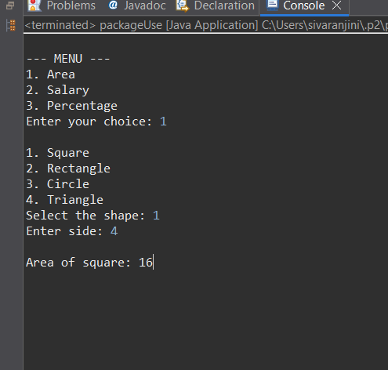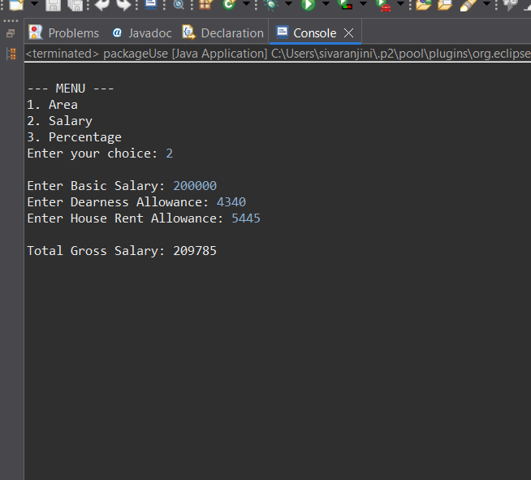
POST LAB EXERCISE
- Find the key differences between java.util and java.lang packages.
Feature | java.lang | java.util
Purpose | Contains fundamental/essential classes required for basic Java programming. | Contains utility classes that support data structures, collections, and utilities.
Automatic Import | Automatically imported in every Java program. | Not automatically imported — must be imported manually.
Examples of Classes | String, Math, Object, System, Thread, Wrapper classes (Integer, Double, etc.) | ArrayList, HashMap, Collections, Date, Scanner, Random, Stack, LinkedList
Type of Classes | Core language classes needed for JVM and basic operations. | Helper classes for advanced operations like data storage, searching, sorting, etc.
Main Use | Base functionality — strings, numbers, threads, exceptions, OOP core. | Data structures, algorithms, utilities, and tools for working with collections.

- List some of the subpackages of java.util
- java.util.concurrent — classes for multithreading and concurrency (Executor, Locks, etc.)
- java.util.concurrent.atomic — atomic (thread-safe) operations on variables.
- java.util.concurrent.locks — lock mechanisms for threads.
- java.util.function — functional interfaces for lambda expressions.
- java.util.regex — Regular expression classes (Pattern, Matcher).
- java.util.stream — Stream API for functional programming.
- java.util.jar — working with JAR files.
- java.util.prefs — user/system preference data.
- java.util.spi — service provider interfaces.
- java.util.zip — ZIP compression/decompression.

ASSESSMENT

Description | Max Marks | Marks Awarded
Pre Lab Exercise | 5
In Lab Exercise | 10
Post Lab Exercise | 5
Viva | 10
Total | 30
Faculty Signature

Experiment Number : 10 Date: 26-02-26

Implementation of Access Modifiers in Java

Aim:
To Write a Java program to implement different access modifiers.

PRE LAB EXERCISE
QUESTIONS
- What are the 4 access modifiers available in Java?
Java has four access modifiers:
- public – Can be accessed from anywhere.
- private – Can be accessed only within the same class.
- protected – Can be accessed in the same package + subclasses (even in other packages).
- default (no keyword) – Can be accessed only within the same package.

- Which access modifiers can be used in Java to control access to class members?
Class members = variables, methods, constructors.
For these, Java allows:
- public
- private
- protected
- default (package-private)
So all four access modifiers can be used to control access to class members.

IN LAB EXERCISE
Objective
To demonstrate different access modifiers such as Default, Private, Protected and Public using Java programs.
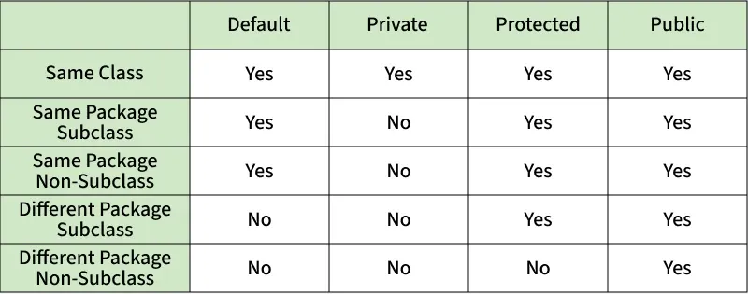
Fig: Comparison table of Access Modifiers in Java
Source Code
// Default Access modifier
package unit2;
class Car {
String model; // default access
}
public class Acress {
public static void main(String[] args){
Car c = new Car();
c.model = "Tesla"; // accessible within the same package
System.out.println(c.model);
}

}
Output:
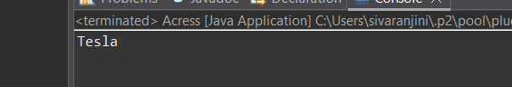

//Private Access Modifier
package unit2;
class Person {
// private variable
private String name;
public void setName(String name) {
this.name = name; // accessible within class
}
public String getName() {
return name;
}
}
public class Acress {

public static void main(String[] args)
{
Person p = new Person();
p.setName("Alice");
// System.out.println(p.name);
// Error: 'name'
// has private access
System.out.println(p.getName());

}

}
Output
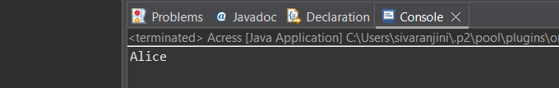

//Protected Access Modifier
package unit2;
class Vehicle {
protected int speed; // protected member
}
class Bike extends Vehicle {
void setSpeed(int s)
{
speed = s; // accessible in subclass
}
int getSpeed()
{
return speed; // accessible in subclass
}
}
public class Acress {
public static void main(String[] args){
Bike b = new Bike();
b.setSpeed(100);
System.out.println("Access via subclass method: "+ b.getSpeed());
Vehicle v = new Vehicle();
System.out.println(v.speed);

}

}
Output
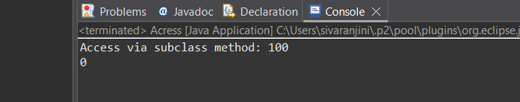

//Public Access Modifier
package unit2;
class MathUtils {
public static int add(int a, int b) {
return a + b;
}
}
public class Acress {
public static void main(String[] args) {
System.out.println(MathUtils.add(5, 10)); // accessible anywhere

}
}
Output

POST LAB EXERCISE
  - Write a Java program to implement Default access modifier which has a default class within the same package and a default class from a different package.
package package1;

// default class (no access modifier)
class DefaultClass1 {
void display() {
System.out.println("Default class in SAME package is accessible!");
}
}
package package1;

public class TestSamePackage {
public static void main(String[] args) {
DefaultClass1 obj = new DefaultClass1(); // allowed
obj.display();
}
}
File 3: /package2/TestDifferentPackage.java
package package2;
import package1.DefaultClass1; // trying to import default class
public class TestDifferentPackage {
public static void main(String[] args) {
DefaultClass1 obj = new DefaultClass1();
obj.display();
}
}
❗ Result
DefaultClass1 is not public in package1; cannot be accessed from outside package

  - Which access modifier provides the highest level of access?
A public class member (method/variable/constructor) can be accessed from anywhere:
  - Same class
  - Same package
  - Different package
  - Subclasses in other packages
So it offers the widest visibility among all access modifiers.

ASSESSMENT

Description | Max Marks | Marks Awarded
Pre Lab Exercise | 5
In Lab Exercise | 10
Post Lab Exercise | 5
Viva | 10
Total | 30
Faculty Signature

Experiment Number :11 Date: 26-02-26

Implementation of multiple inheritance in Java using Interface

Aim:
To Write a Java program to implement multiple inheritance using Interface.

PRE LAB EXERCISE
QUESTIONS
1.Why Java does not support multiple inheritance using classes like that of C?
Java does NOT support multiple inheritance with classes because of the Diamond Problem.
If a class inherits from two parent classes that both have the same method, Java will not know:
- Which parent’s method to execute?
This causes ambiguity.

2.What is the primary purpose of an interface in Java?
- To store data using instance variables
- To define a contract of methods a class must implement
- To allow creation of objects
- To improve runtime performance
ANS:B
to define a contract of methods a class must implement
reason:An interface tells the class:
- “If you implement me, you MUST write these methods.”

IN LAB EXERCISE
Objective
To demonstrate how an interface in Java defines constants and abstract methods, which are implemented by a class.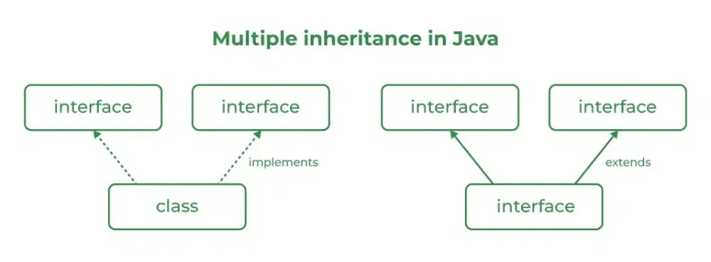

Source Code
package unit2;
import java.io.*;
// Add interface
interface Add{
int add(int a,int b);
}
// Sub interface
interface Sub{
int sub(int a,int b);
}
// Calculator class implementing Add and Sub
class Cal implements Add , Sub
{
// Method to add two numbers
public int add(int a,int b){
return a+b;
}
// Method to sub two numbers
public int sub(int a,int b){
return a-b;
}
}
public class Acress {
// Main Method
public static void main (String[] args){
// instance of Cal class
Cal x = new Cal();
System.out.println("Addition : " + x.add(4,7));
System.out.println("Substraction : " + x.sub(0,1));

}
}

Outputs
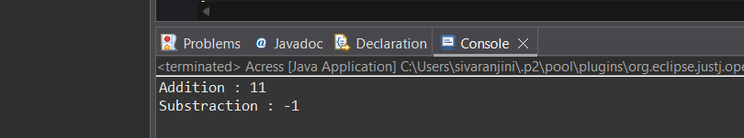
POST LAB EXERCISE
  - Can a functional interface extend another interface?

Yes, a functional interface can extend another interface
BUT only if the parent interface also has exactly one abstract method,
so that the child interface still remains a functional interface.

  - Which feature was introduced in interfaces starting from Java 8?
- Constructors
- Private methods
- Default and static methods
- Final classes
Answer: C. Default and static methods
Why?
From Java 8, interfaces can have:
- default methods (with body)
- static methods (with body)
This was introduced to allow backward compatibility without breaking old code.

ASSESSMENT

Description | Max Marks | Marks Awarded
Pre Lab Exercise | 5
In Lab Exercise | 10
Post Lab Exercise | 5
Viva | 10
Total | 30
Faculty Signature

Experiment Number : 12 Date: 26-02-26

Implementation of exception handling in Java
Aim:
To Write a java program to implement exception handling.

PRE LAB EXERCISE
QUESTIONS
- What is exception handling in Java?
Exception handling is a mechanism in Java used to handle runtime errors so that the program doesn't crash.
It allows the program to:
- Detect errors (exceptions)
- Handle them in a controlled way
- Continue execution smoothly

- What is the purpose of using try-catch blocks in exception handling?
Purpose of try–catch:
try block
Contains the code that might cause an exception.
catch block
Contains the code to handle the exception when it occurs.
- try → “Try to run this risky code.”
- catch → “If something goes wrong, handle it here instead of crashing.”

IN LAB EXERCISE
Objective
To understand and implement exception handling through try-catch and finally blocks.
Source Code
package unit2;
import java.util.InputMismatchException;
import java.util.Scanner;
public class Acress {

public static void main(String[] args) {
Scanner scanner = new Scanner(System.in);
try {
System.out.print("Enter an integer: ");
int num = scanner.nextInt();
int result = 10 / num;
System.out.println("Result: " + result);
} catch (InputMismatchException e) {
System.out.println("Invalid input! Please enter an integer.");
} catch (ArithmeticException e) {
System.out.println("Cannot divide by zero!");
} finally {
scanner.close();
System.out.println("Program execution completed.");
}
}

}
Outputs
Output 1 (Valid Input - Non-zero Integer):

Output 2 (Valid Input - Zero):
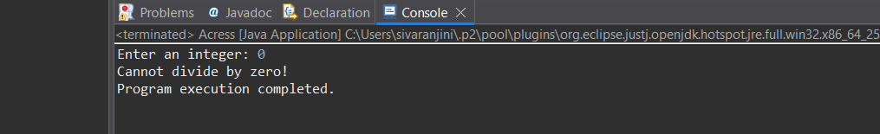
Output 3 (Invalid Input - Non-integer):
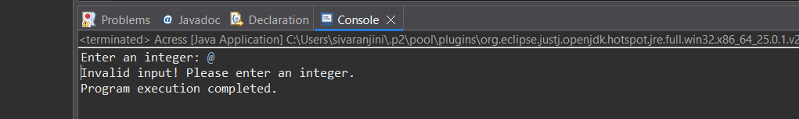

POST LAB EXERCISE
- What is the purpose of the Scanner object in the Java program?
The Scanner object is used to take input from the user at runtime.
It can read:
- integers (nextInt())
- decimals (nextDouble())
- strings (nextLine())
- characters (indirectly)

- What exceptions are expected to be thrown in the code within the try block? Why?
When using Scanner sc = new Scanner(System.in); and reading:
int qty = sc.nextInt();
the common exception is:
InputMismatchException
Why?
This happens when the user enters a value that does not match the expected data type.
Example:
- Program expects an integer
- User enters text like “abc”
→ Java cannot convert this to an int → throws InputMismatchException

ASSESSMENT

Description | Max Marks | Marks Awarded
Pre Lab Exercise | 5
In Lab Exercise | 10
Post Lab Exercise | 5
Viva | 10
Total | 30
Faculty Signature

Experiment Number : 13 Date: 26-02-26

Implementation of User-defined Exception in Java

Aim:
To Write a java program to implement User-defined Exception.

PRE LAB EXERCISE
QUESTIONS
- What is Java custom exception?

A custom exception in Java is a user-defined exception created to handle specific error conditions in a program.
When Java’s built-in exceptions (like NullPointerException, ArithmeticException, etc.) are not enough,
we create our own exception class using:
class MyException extends Exception { }

- What are the two types of custom exceptions in Java?
Java custom exceptions fall into two categories:
1. Checked Custom Exceptions
    - Must extend Exception
    - Checked at compile time
    - Require throws or try–catch
Example:
class InvalidAgeException extends Exception { }

2. Unchecked Custom Exceptions
- Must extend RuntimeException
- Checked at runtime
- No need for throws or try–catch
Example:
class InvalidInputException extends RuntimeException { }

IN LAB EXERCISE
Objective
To understand and implement Checked and Unchecked custom exceptions.
Source Code
package unit2;
class InvalidAgeException extends Exception {
public InvalidAgeException(String m) {
super(m);
}
}
//
public class Acress {

public static void validate(int age)
throws InvalidAgeException {
if (age < 18) {
throw new InvalidAgeException("Age must be 18 or above.");
}
System.out.println("Valid age: " + age);
}
public static void main(String[] args) {
try {
validate(12);
} catch (InvalidAgeException e) {
System.out.println("Caught Exception: " + e.getMessage());
}
}
}

Output 1
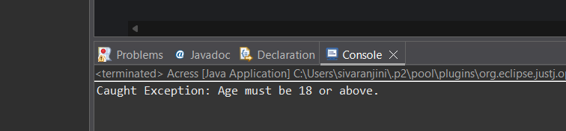
Ex 2: // Custom Unchecked Exception
package unit2;
class DivideByZeroException extends RuntimeException {
public DivideByZeroException(String m) {
super(m);
}
}
public class Acress {
public static void divide(int a, int b) {
if (b == 0) {
throw new DivideByZeroException("Division by zero is not allowed.");
}
System.out.println("Result: " + (a / b));
}
public static void main(String[] args) {
try {
divide(10, 0);
} catch (DivideByZeroException e) {
System.out.println("Caught Exception: " + e.getMessage());
}
}
}

Output 2
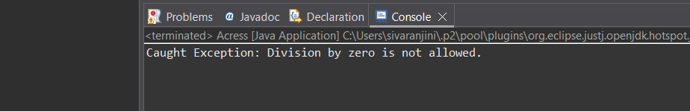
POST LAB EXERCISE
- What is required to create a custom exception in Java?
- Extend the Object class
- Extend the Throwable class
- Extend Exception or RuntimeException
- Implement the Serializable interface
C. Extend Exception or RuntimeException
Why?
To create a custom exception, you must create a class that:
- extends Exception → checked exception
- extends RuntimeException → unchecked exception
- List some use cases for the checked and unchecked exceptions.
Checked Exception Use Cases
Checked exceptions represent predictable, recoverable problems.
Examples:
- FileNotFoundException → When a file is missing.
- IOException → Issues while reading/writing data.
- SQLException → Database connection/query errors.
- ClassNotFoundException → When a required class is not found.
- Custom: InvalidAgeException → e.g., if registering someone below age limit.

Where used?
- File handling
- Database operations
- Network communication
- Input validation scenarios

Unchecked Exception Use Cases
Unchecked exceptions represent programming errors or unexpected conditions.
Examples:
- NullPointerException → Accessing null object
- ArrayIndexOutOfBoundsException → Wrong indexing
- ArithmeticException → Division by zero
- IllegalArgumentException → Wrong method argument
- Custom: InvalidInputException → Wrong value format

Where used?
- Logic errors
- Validation failures
- Incorrect data formats
- Runtime calculations

ASSESSMENT

Description | Max Marks | Marks Awarded
Pre Lab Exercise | 5
In Lab Exercise | 10
Post Lab Exercise | 5
Viva | 10
Total | 30
Faculty Signature

